### Group 4:

### Members: Chhavi Nath

### Devid Kumar

### Badal Singh

### Chandan Kumar

### Disha Shakyawal

### Balusu Devashish

### B N Mallikarjuna

### Product: AT27C256R

#### 1. Overview:

The AT27C256R is a 256K (32K x 8) UV-erasable, One-Time Programmable (OTP) Read-Only Memory (ROM) IC. It belongs to the AT27C series of OTP EPROMs (Erasable Programmable Read-Only Memory), known for their reliability and suitability in applications where the stored data does not need to be altered after programming.

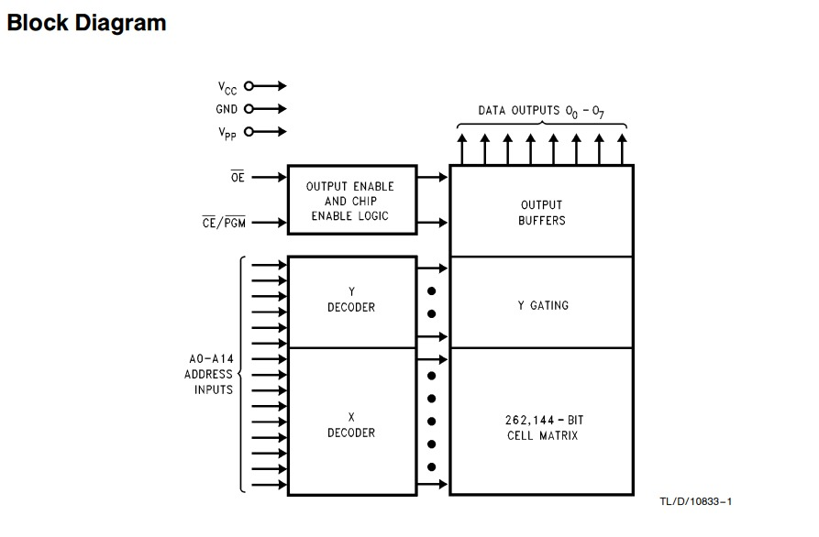

#### 2. Features:

• **Capacity**: 256-Kbit (32-Kbit x 8)

• **Low-power CMOS Operation**: Operates efficiently with low power consumption.

• **Standard Power Supply Range**: Operates on a 5V power supply with a tolerance of +/-10%.

• **Standby Current**: Maximum standby current of 100 µA.

• **Active Current**: Maximum active current of 20mA at 5 MHz operation.

• **Parallel Interface**: Utilizes a parallel interface for data transfer.

• **Access Time**: Fast access time of 45 ns.

• **High-Reliability CMOS Technology**: Built with robust CMOS technology for high reliability.

• **ESD Protection**: Provides 2,000V ESD (Electrostatic Discharge) protection.

• **Latchup Immunity**: Can withstand up to 200 mA of latchup current.

• **Rapid Programming Algorithm**: Offers a rapid programming algorithm with typical programming time of 100 µs per byte.

• **Compatibility**: CMOS and TTL compatible inputs and outputs.

• **Product Identification**: Integrated product identification code for traceability.

• **Temperature Range**: Operates in an industrial temperature range from -40°C to 85°C.

• **Packaging**: Available in Green (Pb/Halide-free) Packaging Only.

#### • **Package Type**: 32-lead, Plastic J-leaded Chip Carrier (PLCC), suitable for various mounting configurations.

#### 3. Applications:

#### One notable example of the 27C256 EPROM in use is in retro computing projects. For instance, it has been used to program and restore vintage computers like the RC2014 Z80 retro computer. This involves programming the EPROM with the original software or firmware needed to run these classic systems

#### Another example is in automotive applications, such as the Honda ECU (Engine Control Unit). The ECU uses a microcontroller that reads firmware from a 27C256 EPROM. This setup is crucial for the proper functioning and tuning of the vehicle’s engine management system.

#### Below are some are general use of above IC in different domains

* **Embedded Systems**: Used in microcontroller-based systems to store firmware, configuration data, and lookup tables that do not require frequent updates.
* **Consumer Electronics**: Integrated into electronic appliances, gaming consoles, and digital devices for storing fixed data such as fonts, graphics, and audio samples.
* **Industrial Automation**: Employed in industrial control systems for storing calibration data, system parameters, and operational firmware.
* **Telecommunications**: Utilized in networking equipment for storing boot code, configuration settings, and protocol data.

#### 4. Advantages and Capabilities:

• **Non-Volatile Storage**: Ensures data integrity even during power loss, maintaining stored information indefinitely.

• **Reliability**: Built to withstand tough environmental conditions common in industrial and automotive settings, ensuring consistent performance over time.

• **Ease of Integration**: Facilitates seamless integration into existing digital systems due to its standardized pin configuration and compatibility with established protocols.

• **Cost-Effective**: Offers an economical solution for applications requiring permanent data storage, eliminating the need for frequent reprogramming.

• **Standard Device**: Provides durability with 10,000 write cycles and a write time of 10 ms, ensuring reliable data storage and retrieval.

• **High Endurance Option**: Features extended durability with 100,000 write cycles, suitable for applications demanding frequent data updates.

• **Fast Write Option**: Allows quick data programming with a write time of 3 ms, optimizing operational efficiency in time-sensitive applications.

### Conclusion:

The AT27C256R ROM IC from Microchip Technology is a reliable and widely-used solution for storing fixed data in various digital applications. Its combination of features, including non-volatile storage, wide operating voltage range, and fast access times, makes it suitable for a broad range of industries including automotive, consumer electronics, and industrial automation. This ROM IC is ideal for applications where the stored data remains static after programming, offering a robust and cost-effective solution for data storage needs.

Top of Form

Bottom of Form